Special Educational Needs and Disabilities (SEND) Information Report

St Francis Catholic Primary School

‘A community growing in love for learning
and life rooted in God’s love’.

SEND Governor:
Mrs S Regan
Inclusion Lead & SENCO
Mrs S Neill
Contact No. 01622 771540
Email: sen@stfranciscatholicprimary.com

Approved by: |  | Date:
Last reviewed on: | February 2025
Next review due by: | February 2026

Contents

1. What types of SEND does the school provide for? 4
2. Which staff will support my child? 5
3. What should I do if I think my child has SEND? 7
4. How will the school know if my child needs SEN support? 8
5. How will the school consult with me about my child ? 10
6. How will the school measure my child’s progress? 13
8. How will the school adapt its teaching for my child? 14
9. How will the school evaluate whether the support in place is helping my child? 17
10. How will the school ensure my child has appropriate resources? 18
11. How will the school make sure my child is included in activities alongside pupils who don’t have SEND? 19
12. How does the school make sure the admissions process is fair for pupils with SEN or a disability? 19
13. How does the school support pupils with disabilities? 20
14. How will the school support my child’s mental health and emotional and social development? 20
15. What support is in place for looked-after and previously looked-after children with SEN? 21
16. What support will be available for my child as they transition between classes or settings or in preparing for adulthood? 21
17. What support is available for me and my family? (Local Offer) 23
18. What should I do if I have a complaint about my child’s SEND support? 24
19. Supporting Documents 24
20. Glossary 20

Dear parents and carers,
The aim of this Information Report is to explain how we implement our SEND policy. In other words, we want to show you how SEND support works in our school.
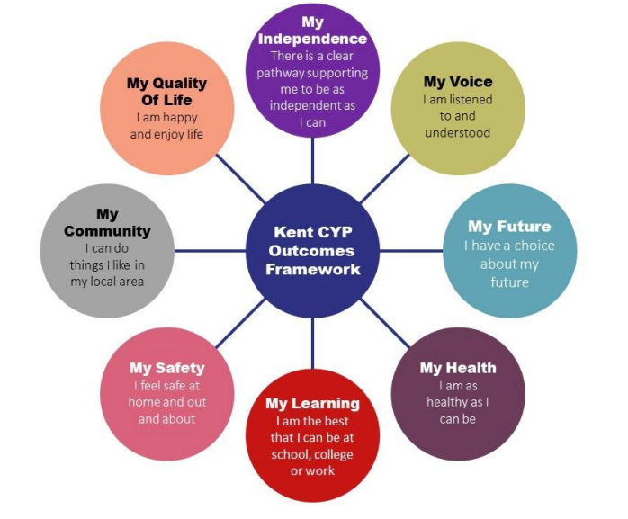
As educational professionals, we are all working towards the ultimate goal of growing independent young people as they prepare for adulthood. All provision and support we provide is working towards achieving the Kent Children and Young People (CYP) Outcomes Framework:

If you want to know more about our arrangements for SEND, read our SEND policy alongside this Information Report.
You can find our SEND policy on our website https://www.st-francis.kent.sch.uk/
Note: If there are any terms we’ve used in this information report that you’re unsure of, you can look them up in the Glossary at the end of the report.

1. What types of SEND does the school provide for?

Our school provides for pupils with the following needs (as outlined in the SEND Code of Practice 2015):

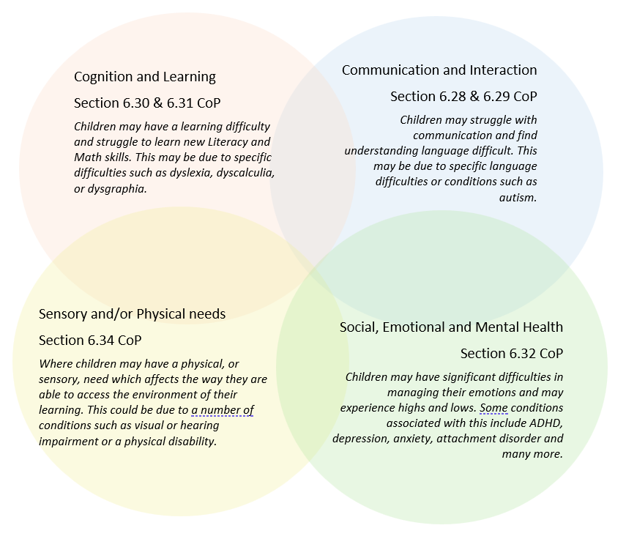

Often you will find that children’s needs overlap and are rarely confined to one area of need, which is why it is important to gain a holistic overview of your child.
More information about the Areas of Need can be found in the Special educational needs and disability code of practice: 0 to 25 years (link below).
SEND_Code_of_Practice_January_2015.pdf (publishing.service.gov.uk)


2. Which staff will support my child
At St Francis all staff are considered responsible for supporting the needs of pupils with SEND. Our staff are committed to regular, high-quality training to ensure that they have the knowledge and skills to better meet a wide range of pupil needs.
Below outlines key staff who will be supporting your child. Please note that this list is not exhaustive.

Our Special Educational Needs Co-ordinator, or SENCO
Mrs Neill has overall responsibility for SEND provision in our school. She is a qualified teacher working towards the National Award for Special Educational Needs Coordination. She undergoes continuing professional development to enhance her own knowledge of SEND, which can then be disseminated to other staff members as appropriate.

Class Teams
All classes at St Francis have a qualified teacher and at least one teaching assistant. We are committed to developing the ongoing expertise of all our staff. Both in-house and external training opportunities are provided for all staff to enhance their skills and knowledge in the delivery of Quality First Teaching, evidence based interventions and in areas of specific SEND need, including social, emotional & mental health needs. Our teaching assistants are trained to deliver a range of interventions to support children’s academic, social and emotional progress. Training opportunities offered to staff throughout the year will be linked to the needs of the current cohort of children.

External agencies
Sometimes we need extra help to offer our pupils the support that they need. Whenever necessary we will work with external support services to meet the needs of our pupils with SEND and to support their families. These may include:

- Child and adolescent mental health services (CAMHS)
- Education welfare officers
- Educational psychologists
- GPs or paediatricians
- NELFT practitioners
- Occupational therapists
- Therapeutic practitioners
- Emotional literacy support assistants
- Safeguarding services
- School Liaison Officer
- School nurses
- SEND Inclusion Advisor
- Specialist Teaching and Learning Services
- Speech and language therapists



- Voluntary sector organisation


3. What should I do if I think my child has SEND?

At St Francis, we aim to identify and assess the needs of all pupils as early as possible in order to ensure early identification and intervention for any SEND and to support the pupil in making good progress. Underpinning all our provision in school is the graduated approach cycle of: Assess, Plan, Do and Review.

If you have concerns about your child, the following process will be followed:
Step 1: Concerns Raised (Assess & Plan) If you think your child might have an additional need that requires further support, arrange a phone call or meeting with the class teacher to discuss your concerns. The class teacher will share support that is already in place and agree on any further strategies to implement. They may seek the advice of the SENCO when planning these strategies. They are likely to be universal strategies set out in the Kent Mainstream Core Standards.
Step 2: Monitor & Implement (Do) The class teacher will implement the agreed strategies and monitor these over a period of time, usually 6-12 weeks. During this time, they may continue to seek the support of the SENCO to ensure strategies are appropriate and effective.

Step 3: Review & Agree Next Steps (Review) School staff will review the strategies and either adjust or continue these. If there are still concerns, the SENCO will become involved and may contact you to arrange a meeting. In-school assessments may be used to further identify your child’s strengths and challenges.
If you still have concerns after the agreed monitoring period, contact the SENCO to discuss these further.
The same process is followed if a concern is raised by the school

4. How will the school know if my child needs SEN support?
The SEND Code of Practice 2015 states that a child has SEND If they have a learning difficulty or disability which calls for special education provision to be made for them which is different or additional to that given to their peers.
A child has a learning difficulty or disability if they:
- Have a significantly greater difficulty in learning than the majority of others of the same age; or
- Have a disability which prevents or hinders them from making use of facilities of a kind generally provided for others of the same age within a mainstream school.

At St. Francis we assess the needs of all pupils at the earliest possible opportunity to ensure the early identification of any SEND and to ensure all children make good progress. A range of criteria is taken into consideration when identifying SEN, including:
- The child’s early history
- Medical diagnoses which may impact learning
- Parental concern
- Low entry profile
- Attainment in the National Curriculum which is significantly lower than the expected for their age
- A lack of progress despite access to high quality teaching and a differentiated curriculum
- Requiring greater attention in class due to behavioural or learning difficulties
- Requiring specialist material or equipment or support for sensory or physical challenges

We monitor the progress of all pupils three times a year to review their academic progress. We also use a range of assessments with all the pupils at various points e.g., Year 1 Phonics screening, Speech Link, Language Link, spelling age, reading age tests, Pixl. Assessments and SATS. Where progress is not sufficient, even if a special educational need has not been identified, we put in place extra support to enable the pupil to work towards catching up. Examples of extra support are: targeted intervention for maths, phonics, reading comprehension, writing, handwriting, social and emotional wellbeing, fine or gross motor skills, sensory circuits, speech and language. Some pupils may continue to make inadequate progress, despite high-quality teaching targeted at their areas of weakness. For these pupils, and in consultation with parents, we will use a range of assessment tools to determine the cause of the learning difficulty. At St. Francis we are experienced in using the following assessment tools:
- Lucid Cops and Lucid Lass for identifying strengths and weaknesses in learning and possible indicators of dyslexia
- Infant / Junior Language Link for evaluating the development and understanding of language
- Speech Link for the evaluation of speech sound production
- Language for learning screening
- Leuven Scales for wellbeing and involvement
- The Boxall Profile for Social, emotional and behavioural development
- Curtis Scale diagnostic and developmental assessment of emotional / social wellbeing
- Ravens Matrices IQ Test for evaluation of non-verbal ability
- BPVS (British Picture Vocabulary Scale for evaluation of receptive vocabulary
- Sensory circuit checklist
- Social, communication and interaction scale
- Expressive vocabulary test

We also have access to external advisors such as the specialist teaching and learning service, educational psychologist, physiotherapy, speech and language therapy, occupational therapy, school nurse, play therapy, ELSA, Thrive, early help services and social services who are able to use more specialist assessment tools. The purpose of this more detailed assessment is to understand what additional resources and alternative approaches are required to enable the pupil to make better progress. These will be shared with parents, put into a SEN support plan and reviewed regularly, and refined / revised if necessary. At this point we will have identified that the pupil has a special educational need because the school is making special educational provision for the pupil which is additional and different to what is normally available. If the pupil is able to make good progress using this additional and different resource (but would not be able to maintain this good progress without it) we will continue to identify the pupil as having a special educational need. If the pupil is able to maintain good progress without the additional and different resources they will no longer be identified with special educational needs. When any change in identification of SEN is changed parents will be notified. All teachers and support staff who work with the pupil are aware of the support to be provided and the teaching approaches and adaptations to be used.

All our class teachers are responsible for the monitoring of all pupils who have been identified as having SEND. They also review those who are not making the expected level of progress in their schoolwork or socially.

5. How will the school consult with me about my child?
All parents of pupils at St. Francis Primary School are invited to discuss the progress of their children on three occasions during the year. They receive a written report at the end of the year. We will have an early discussion with the pupil and their parents when identifying whether they need special education provision.
These conversations will make sure that:
- Everyone develops a good understanding of the pupil’s areas of strength and difficulty
- We take into account the parent’s concerns
- Everyone understands the agreed outcomes sought for the child
- Everyone is clear on what the next steps are
Notes of these early discussions will be added to the pupil’s record and shared with the parent. We will notify parents when it is decided that a pupil will receive SEN support. In addition, we are happy to arrange meetings outside these times. As part of our normal teaching arrangements, all pupils will access some additional teaching to help the catch-up if the progress monitoring indicates that this is necessary; this will not imply that the pupil has a special educational need.
All such provisions will be recorded, tracked and evaluated on a Provision Map. If following this normal provision improvements in progress are not seen, we will contact parents to discuss the use of internal or external assessments which will help us to address these needs better. From this point onwards the pupil will be identified as having special education needs because special educational provision over and above our universal offer is being made. Parents will be actively supported to contribute to assessment, planning and review.
Parents of pupils with an Education, Health and Care Plan, will be invited to contribute to and attend an annual review, which, wherever possible will also include other agencies involved with the pupil, all information will be made accessible for parents / carers.
When a pupil has been identified to have special educational needs, they will be consulted about and involved in the arrangements made for them as part of person-centred planning (where appropriate). Parents are likely to play a more significant role in the early childhood years with the young person taking more responsibility and acting with greater independence in later years. Pupils’ views are sought for Annual Reviews of EHCP’s, Pupil views are included as part of learning walks and ongoing monitoring of teaching and learning. Self-assessment is encouraged as an integral part of pupil learning.

How will I be involved in decisions made about my child’s education?
We will provide a written report on your child's progress at the end of each academic year. You will have the opportunity to meet with your child’s class teacher three times per academic year, to:
- Set clear outcomes for your child’s progress
- Review progress towards those outcomes
- Discuss the support we will put in place to help your child make that progress
- Identify what we will do, what we will ask you to do, and what we will ask your child to do.
The SENCO may also attend these meetings to provide extra support. We know that you’re the expert when it comes to your child’s needs and aspirations. So, we want to make sure you have a full understanding of how we’re trying to meet your child’s needs, so that you can provide insight into what you think would work best for your child. We also want to hear from you as much as possible so that we can build a better picture of how the SEN support we are providing is impacting your child outside of school.

How will my child be involved in decisions made about their education?
The level of involvement will depend on your child’s age and individual needs. We recognise that no two pupils are the same, so we will decide on a case-by-case basis, with your input.

We may seek your child’s views by asking them to:
- Attend meetings to discuss their progress and outcomes
- Prepare a presentation, written statement, video, drawing, etc.
- Discuss their views with a member of staff who can act as a representative during the meeting
- Complete a survey



6. How will the school measure my child’s progress?

We will follow the ‘graduated approach’ to meeting your child’s SEND needs.
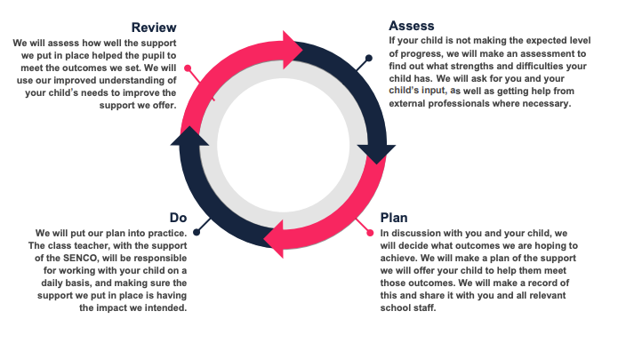
The graduated approach is a 4-part cycle of assess, plan, do, review.
The class teacher will work with the SENCO to carry out a clear analysis of the pupil’s needs.
This will draw on:
- The teacher’s assessment and experience of the pupil
- The previous progress and attainment or behaviour
- The individual’s development in comparison to their peers and national data
- The views and experience of parents
- The pupil’s own views
- Advice from external support services, if relevant
As a part of the planning stage of the graduated approach, we will set outcomes that we want to see your child achieve. Whenever we run an intervention with your child, we will assess them before the intervention begins. This is known as a ‘baseline assessment’. We do this so we can see how much impact the intervention has on your child’s progress. We will track your child’s progress towards the outcomes we set over time and improve our offer as we learn what your child responds to best. This process will be continual. If the review shows a pupil has made progress, they may no longer need the additional provision made through SEN support. For others, the cycle will continue and the school's targets, strategies and provisions will be revisited and refined.

8. How will the school adapt its teaching for my child?

High quality teaching, with scaffolded access and differentiated for individual pupils, is the first step in responding to pupils who have or may have SEN. Additional intervention and support cannot compensate for a lack of good quality teaching. The school regularly and carefully reviews the quality of teaching for all pupils, including those at risk of underachievement. This includes reviewing and, where necessary, improving, teachers’ understanding of strategies to identify and support vulnerable pupils and their knowledge of the SEN most frequently encountered SEN Code of Practice (2015, 6.37).

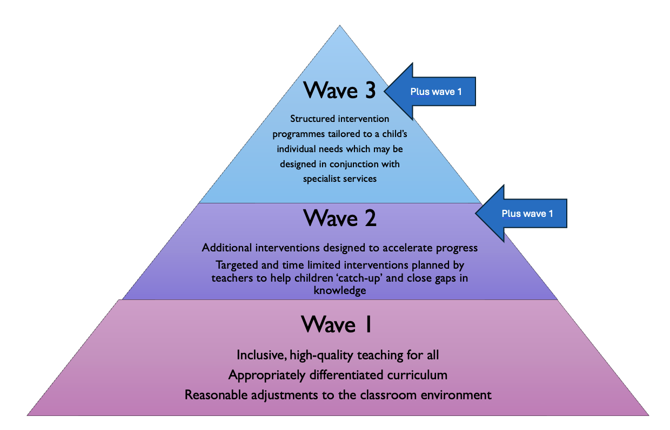
At St. Francis Primary school we follow the Mainstream Core Standards advice developed by Kent County Council to ensure that our teaching conforms to best practice. In meeting the Mainstream Core Standards, the school employs some additional teaching approaches, as advised by internal and external assessments e.g., one to one tutoring / precision teaching / mentoring, small group teaching, use of ICT software learning packages, these are delivered by additional staff employed through the funding provided to the school as ‘notional SEN funding’. Where a child requires further support, the school uses the graduated approach to plan and deliver appropriate interventions for the child. We use a tiered approach to support:

Examples of adaptations:

AREA OF NEED | DETERMINATION OR DIAGNOSIS | POSSIBLE ADAPTATIONS
Communication and interaction | Autism Spectrum Disorder  Speech and language difficulties  Developmental Language Delay | Visual timetables and supports  Social stories  Comic strips  Talk About Social Skills  Talk About Self Esteem  Zones of Regulation  Anxiety Gremlins  Lego Therapy  Emotional check-ins  Mentoring  Alternative communication methods (e.g., PECS)  Flexible seating  Sensory support (e.g., ear defenders)  Speech and language therapy  Speech Link  Language Link  Phonological Awareness Programme  Nessy
Cognition and Learning | Specific learning difficulties, including dyslexia, dyspraxia and dyscalculia  Moderate and severe learning difficulties | Writing slope  Pencil grips  Literacy Gold (formerly Dyslexia Gold)  Lexia 1:1  Assisted technology (e.g., text-to-speech)  Reading pen  Toe by Toe  Ace dictionary  Alphabet Arc  Alternative recording methods  Visual aids and checklists  Pixl Interventions Booster Groups  Daily Readers  Lightening Squad  Clever Fingers (fine motor skills development)  BEAM (gross motor skills development)  Precision teaching  Colourful semantics  PECS  Memory boosting activities  Adapted curriculum  Nurturing activities
Social, Emotional and Mental Health | ADHD, ADD  Emotional dysregulation  Oppositional Defiant Disorder  Anxiety Disorders | Quiet workstation  Sensory Circuits  Nurture groups  Visual supports and prompts  Task management Boards Widget  Ear defenders  Behaviour support plans  Thrive  ELSA  Play therapy  Adjusted timetables  Zones of regulation  Emotional check ins  Adapted curriculum  Mentor
Sensory and/or physical | Chronic health conditions  Physical impairment  Hearing impairment  Visual impairment  Multi sensory impairment  Sensory processing disorder | Health care plans  Assisted technology  Flexible timetables  Specialist teaching service  Safe spaces  Calming activities  Nurture activities  Transition preparation  Ear defenders  Sensory break opportunities Help / exit indicators  Visual aids
These interventions are part of our contribution to Kent County Council’s local offer.

9. How will the school evaluate whether the support in place is helping my child?

St. Francis primary school has a robust self-assessment system in place which includes learning walks, lesson observations, book scrutiny and pupil voice interviews, all of which includes monitoring provision for pupils with SEN. Interventions are discussed with the Class teacher at Pupil Progress Meetings in the presence of the ENCO and Headteacher.
Appropriate targets are set for all children and these are regularly reviewed. All interventions, and the impact of these, are monitored by the SENCO. Each review of the SEN support plan will be informed by the views of the pupil (where appropriate), parents, class teachers and SENCO and the assessment information from teachers which will show whether adequate progress is being made.
The SEN Code of Practice (2015, 6.17) describes inadequate progress thus:
- Is significantly slower than that of their peers starting from the same baseline
- Fails to match or better the child’s previous rate of progress
- Fails to close the attainment gap between rate of progress
- Widens the attainment gap
For pupils with an Education, Health and Care Plan there will be an annual review of the provision made for the child, which will enable an evaluation of the effectiveness of the special provision. The collation of all annual review evaluations of effectiveness will be reported to the governing body

10. How will the school ensure my child has appropriate resources?

As part of our budget, we receive ‘notional SEN funding’. This funding is used to ensure that the quality of teaching is good in the school and that there are sufficient resources to deploy additional and different teaching for pupils requiring SEN support. The amount of support required for each pupil to make good progress will be different in each case and a full list of the interventions we can offer is on our class provision maps. In very few cases a very high level of resource is required. The funding arrangements require schools to provide up to £6000 per year of resource for pupils with high needs, and above that amount the Local Authority should provide top up to the school. The school applies for this top up for pupils with a level of need that cannot be met through our universal offer of normal targeted interventions. If the situation arises whereby a child requires specialist expertise, the school will work with the Local Inclusion Forum Team (LIFT) to identify and allocate the most suitable specialist teacher within the area. In addition to this, the school can also make referrals for support from paediatricians, speech and language therapists, mental health support, occupational therapy, school nurses and other available external support services. We have a team of teaching assistants who are trained to deliver a range of interventions to support children’s academic, social and emotional progress. Training opportunities offered to staff throughout the year will be linked to the needs of the current cohort of children.

11. How will the school make sure my child is included in activities alongside pupils who don’t have SEND?

All clubs, trips and activities offered to pupils at St. Francis Primary School are available to pupils with special educational needs either with or without an Education, Health and Care Plan. Where it is necessary, the school will use the resources available to it to provide additional adult support to enable the safe participation of the pupil in the activity. Parents and carers are consulted and involved in additional planning so adaptations can be made to allow participation. Individual risk assessments may be put in place to support this process and specialist services may be consulted.
No pupil is ever excluded from taking part in these activities because of their SEN or disability and we will make whatever reasonable adjustments are needed to make sure that they can be included. We have an accessibility policy and action plan which further details how we ensure children with SEND are included in daily school life.

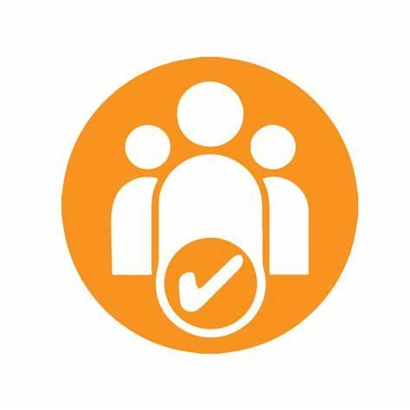
12. How does the school make sure the admissions process is fair for pupils with SEN or a disability?

St Francis has an admissions policy that outlines our processes and oversubscription criteria which apply to all children seeking a place at our school, including those with SEND. Where a child has an EHCP and St Francis is named as the most appropriate school, priority for admission will be given to that child. If your child has SEND and you are considering St Francis as a school placement, you are welcome to contact the SENCO to discuss how they would be supported. We may also arrange additional transition information and tours of the school if appropriate.

13. How does the school support pupils with disabilities?

You’re disabled under the Equality Act 2010 if you have a physical or mental impairment that has a ‘substantial’ and ‘long-term’ negative effect on your ability to do normal daily activities.
St Francis has an inclusive approach to all aspects of the curriculum. All children, regardless of need, are encouraged to participate in all aspects of school life. To ensure access to the physical school environment, our school has accessible classrooms and a disabled toilet. Where further physical adaptations to the learning environment are required, the school may work with external agencies such as Occupational Therapy and the STLS to make changes so our learning environment is accessible to all. We have an accessibility policy and action plan which further details how we ensure children's disabilities are included in daily school life.

14. How will the school support my child’s mental health and emotional and social development?

At St. Francis Primary School we understand that an important feature of the school is to enable all pupils to develop emotional resilience and social skills, both through direct teaching for instance e.g., PSHE, circle time activities, assemblies and school rules and indirectly with all conversation adults have withy pupils throughout the day.
For some pupils with the most need for help in this area we also can provide the following e.g., access to learning / behaviour mentor, counsellor or therapist, mentor time, ELSA, external referral to CYPS, time-out space for pupils to use when upset or agitated etc. Pupils in the early stages of emotional and social development because of their special educational needs will be supported to enable them to develop and mature. This will often require additional and different resources, beyond that required by pupils who do not need this support.
The school has a Family Liaison Officer (FLO) whose primary role is to work with families to ensure the wellbeing of all family members is protected and to signpost to appropriate supportive services and resources where required.


15. What support is in place for looked-after and previously looked-after children with SEND?

Miss Butler, Assistant Head, will work with our SENCO, to make sure that all teachers understand how a looked-after or previously looked-after pupil’s circumstances and their SEN might interact, and what the implications are for teaching and learning. Children who are looked-after or previously looked-after will be supported much in the same way as any other child who has SEND. However, looked-after pupils will also have a personal education plan (PEP). We will make sure that the PEP and any SEN support plans or EHC plans are consistent and complement one another.

16. What support will be available for my child as they transition between classes or settings or in preparing for adulthood?

Joining from another setting
When a child is moving from a pre-school setting to our Reception, all parents and carers and carers are invited to attend a welcome meeting with the Headteacher and to take a tour of the school.
Where a child has identified SEND or parents and carers have concerns about potential SEND, they are encouraged to make an appointment with the SENCO prior to starting.
Additional transition support can be arranged for children with SEND including attendance at pre-school Annual Reviews, additional visits to St Francis and observations of the child within their pre-school setting.
When a pupil joins us part-way through their school journey, we liaise closely with staff at their previous setting to ensure all relevant paperwork is passed on and all needs are discussed and understood.
Where there is identified SEND, we will liaise with previous settings and, where appropriate, involve professionals to ensure relevant support is in place as soon as the child starts with us.
Moving into a new year group
When moving through the primary years, transition books are prepared to provide key information to the pupils with SEND about their new class and class teacher. This also provides the class teacher with key information about the child’s needs and how best to support them.
Detailed handover meetings take place when children move to a new year group, including discussions with the SENCO, to ensure relevant interventions and support are in place as soon as they begin in their new year group.
As part of the transition process all children have at least one session with their new teacher in their new classroom, prior to the summer, where necessary children with SEND are provided the opportunity for more visits with their new teacher.

Leaving to join a new school
When pupils with SEND are preparing to leave us to go to a new school, typically to secondary education, we can arrange additional visits to their new school.
All notes, files and information are passed onto the secondary schools.
Transition Annual Reviews are held for those pupils who have EHCPS and secondary school staff are invited to attend.

17. What support is available for me and my family?


If you have questions about SEND, or are struggling to cope, please get in touch to let us know. We want to support you, your child and your family. Details of support locally can be found on Kent’s Local Offer. The “Local Offer” provides information about SEND in a single place. It intends to provide families with information about the support and services available for children with SEND within the local area, including useful contact details and information about children and parents and carers’ statutory entitlements.

There are a number of local information, advice and support services that can provide support to families of children with SEND, including:
- Information and Advice Service Kent (IASK)
- The Autism Apprentice
- Space2Be Me
National charities that offer information and support to families of pupils with SEND include:
- IPSEA
- SEND family support
- NSPCC
- Family Action
- Special Needs Jungle

18. What should I do if I have a complaint about my child’s SEND support?
We encourage parents and carers to come and talk to us about any concerns they may have about their child or the provision being made for them. Parents and carers who are still concerned following that discussion should follow the school’s complaints procedure.
We encourage parents to discuss their concerns with the class teacher, the SENCO or Headteacher to resolve the issue before making the complaint formal to the Chair of the governing body. If the complaint is not resolved after it has been considered by the governing body, then a disagreement resolution service or mediation service can be contracted. If it remains unresolved after this then a full explanation of suitable avenues for complaint, see pages 246 and 247 of the SEN Code of Practice. If you feel that our school discriminated against your child because of their SEND, you have the right to make a discrimination claim to the first-tier SEND tribunal. To find out how to make such a claim, you should visit: https://www.gov.uk/complain-about-school/disability-discrimination
You can make a claim about alleged discrimination regarding:
- Admission
- Exclusion
- Provision of education and associated services
- Making reasonable adjustments, including the provision of auxiliary aids and services
Before going to a SEND tribunal, you can go through processes called disagreement resolution or mediation, where you try to resolve your disagreement before it reaches the tribunal. For more information about mediation visit https://www.globalmediation.co.uk/service/special-educationalneeds-disability/

19. Supporting documents
- SEND Policy
- Accessibility Policy and Plan
- Admission Policy
- Complaints Procedure
- SEN & Disabilities Code of Practice 2015
- Kent Mainstream Core Standards

20. Glossary
- Access arrangements – special arrangements to allow pupils with SEND to access assessments or exams
- Annual review – an annual meeting to review the provision in a pupil’s EHC plan
- Area of need – the 4 areas of need describe different types of needs a pupil with SEND can have. The 4 areas are communication and interaction; cognition and learning; physical and/or sensory; and social, emotional and mental health needs.
- CAMHS – child and adolescent mental health services
- Differentiation – when teachers adapt how they teach in response to a pupil’s needs
- EHC needs assessment – the needs assessment is the first step on the way to securing an EHC plan. The local authority will do an assessment to decide whether a child needs an EHC plan.
- EHC plan – an education, health and care plan is a legally-binding document that sets out a child’s needs and the provision that will be put in place to meet their needs.
- First-tier tribunal/SEND tribunal – a court where you can appeal against the local authority’s decisions about EHC needs assessments or plans and against discrimination by a school or local authority due to SEND
- Graduated approach – an approach to providing SEND support in which the school provides support in successive cycles of assessing the pupil’s needs, planning the provision, implementing the plan, and reviewing the impact of the action on the pupil
- Intervention – a short-term, targeted approach to teaching a pupil with a specific outcome in mind
- Local offer – information provided by the local authority which explains what services and support are on offer for pupils with SEND in the local area
- Outcome – target for improvement for pupils with SEND. These targets don't necessarily have to be related to academic attainment
- Reasonable adjustments – changes that the school must make to remove or reduce any disadvantages caused by a child’s disability
- SENCO – the special educational needs co-ordinator
- SEN – special educational needs
- SEND – special educational needs and disabilities
- SEND Code of Practice – the statutory guidance that schools must follow to support pupils with SEND
- SEND information report – a report that schools must publish on their website, that explains how the school supports pupils with SEND
- SEND support – special educational provision which meets the needs of pupils with SEND
- Transition – when a pupil moves between years, phases, schools or institutions or life stages

